

GenC FTE Skilling Program Guidelines 2026

Table of Contents

- Introduction 4
- Scope of the document 4
- Purpose 4
- GenC Program Overview 4
- Acronyms and Definitions 6
Acronyms 6
DEFINITIONS 6
- Skilling completion criteria for GenC FTE 7
  - Technical Competencies 7
    - Stage 1 8
    - Stage 2 and beyond (Advanced skilling stages) 8
      - RAG Definition 9
      - Skilling completion criteria from Stage 2 and attempt eligibility 10
      - Gating criteria Beyond Stage 2 10
    - Exceptions to evaluation components 10
      - EPS B.COM hiring selects 10
Note 11
      - Profiling Assessment 11
      - Autonomous Interview Agent (AIA BOT)
- Attendance health Status 11
- GenC FTE skilling program guidelines 12
  - Code of Ethics - Guiding Principles 13
    - Employee Relations matters 14
  - Attendance Health score Guidelines 14
    - AHS RAG 14
    - AHS Consequence 15
    - FTE leave policy 15
    - Break Scenario 15
  - Integrity in Assessments 16
    - What constitutes Malpractice 16
  - Deployment guidelines 16
  - Communication protocols 17
    - GenC Program Communication Escalation Matrix 17
    - Mail format 17
- GenC Grievance cell 18
  - How does the grievance cell work? 18
  - Grievance Categories 19
- Feedback communication to the GenC 19
- Outliers/Exceptions 19

Introduction
The Generation Cognizant Program (GenC Program) caters to the Entry Level Training within Cognizant in India. stretches across the entire timeline of a campus hire's learning journey from the time he/she accepts the offer letter from the company - to the first year of his/her tenure in the organization. There is a robust learning strategy put in place across each of the stages:

- Pre-Onboarding (Early Engagement, Campus engagement, Internship, Certified skill development)
- GenC FTE training
- Year One Enablement
- Continuous Role Development

Scope of the document
This document covers the guidelines for GenC Full time Employee (FTE) trainees in Cognizant at India for On–Campus and Off-campus selects going through Cognizant GenC skilling program enablement via Classroom/Virtual / Hybrid (Classroom & Virtual) mode in the year 2025. These guidelines are applicable to all types of skilling programs (Skilling/Re-skilling pre & post onboarding to the skilling program)
The duration and exit criteria of the GenC FTE skilling program will be determined by the curriculum track to which the GenC is mapped as per the business demand. (Refer to Stage2 for details)

Purpose
The purpose of this document is to define the approach towards Cognizant GenC FTE 2025 skilling completion from the LnD GenC Program standpoint.

The GenC curriculum is designed with a focus on enabling GenC FTE trainees to incorporate the skills acquired by developing real time projects/use cases, as well as considerably improve their professional skills as they progress through the program.

GenC Program Overview
The GenC (Generation Cognizant) Program assures skill capability in our fresh hires (GenCs) towards business readiness at Cognizant. This program spans the entire duration of GenCs learning journey, from the time GenCs accept Cognizant offer, through the first-year completion as an FTE in the organization. There is a robust learning strategy put in place across four phases.
In the Cognizant GenC skilling program, the FTE trainees are provided with a learning path, and their performance is assessed based on milestones in the curriculum. This includes meeting the gating criteria for the assigned curriculum, completing learning assessments, and hands-on assignments as per the given schedule, and adhering to the skilling program guidelines.

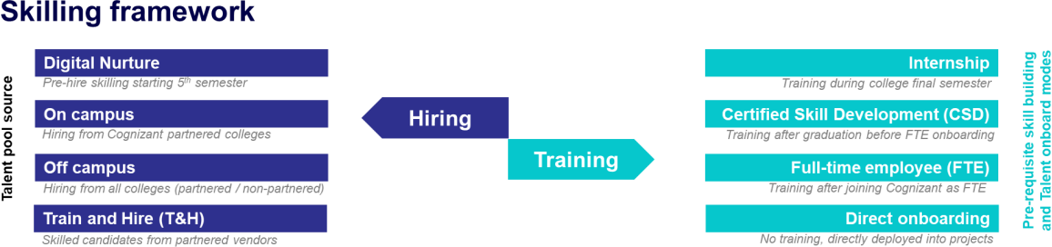

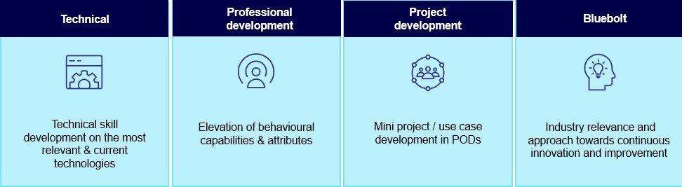

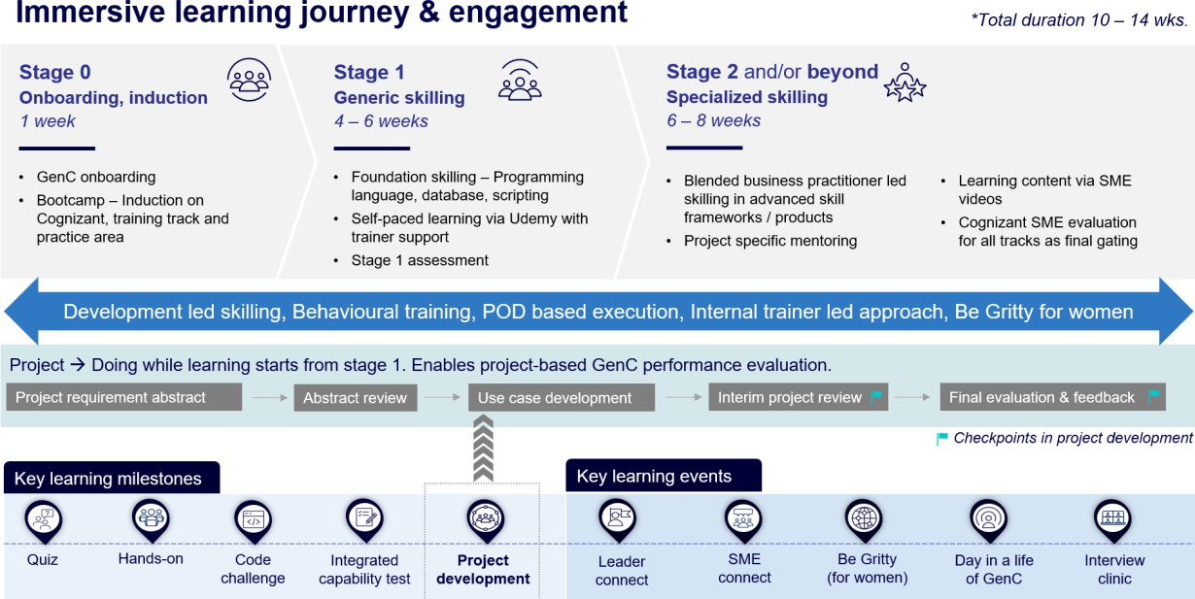

Acronyms and Definitions
Few of the acronyms and / or its definitions provided here may not have been used in this document but has been provided for easy reference to their definitions.

Acronyms
Acronym | Description
GenC | Generation Cognizant
SL | Service Line
BU | Business Unit
FTE | Full Time Employee
PHS | Performance Health Status
AHS | Attendance Health Status (Score)
RAG | Red, Amber, Green
LOI | Letter of Intent

DEFINITIONS

Component | Description | Examples
Learning and Evaluation Components | The broad parameters that will be applicable for all types of enablement, based on which the evaluation and completion criteria would be determined. | Continuous Learning (Technical & Behavioral  – if applicable) Hands-on exercises  Qualifier assessments  Interim Technical & Project Evaluation Final Technical & Project Evaluation
Type of Curriculum | The learning path can follow any of the predefined structures as designed by Cognizant GenC skilling program.  Alternatively, based on the business demand; to meet the expectations of learning outcome, customizations would be applied the existing defined learning path [a joint venture between the Service Line (SL) and GenC program team]  A completely niche learning path could be designed by Business team | Standard Skill Tracks  GenC program driven  Business Defined Skill Tracks  GenC program + SL driven SL Driven

Component | Description | Examples
 | [referred as Service Line (SL) Driven].
Minimum Score/ Expected Status | The score/status that the GenC should obtain to clear a particular Evaluation Component. The score/Status indicates a completion or a skill/technical score, as per the applicability, for the Evaluation Component. | All score-based Assessments – Evaluation score of 70% and above  PHS to successfully complete the training will  be “Green”
Number of Attempts | Any GenC who has not obtained the pre-defined minimum percentage to clear the Evaluation components will be eligible for reattempt, as applicable. The number of reattempts would be defined for respective evaluation components in the learning path. | 1 or 2, as prescribed for the Evaluation Components
Performance Health Status | Status determined based on the performance by GenC in the evaluation components, applicable for the learning path | Green/Amber /Red status  PHS to successfully complete the training will  be “Green”
AHS  Attendance Health Status | Cumulative attendance Status of the GenC at physical location and virtual training. | Green/Amber /Red status  Time at Office – 10 hours across all India locations [9 hours for Kolkata and NCR]  TruTime Compliance = “Green” (min 9  hours/day)  Attendance in mandatory ILT/VILT sessions

Pre‑Skilling & HiPo Identification Framework

To enhance agility, accelerate deployment readiness, and optimize learning investments, Cognizant may establish a Pre‑Skilling Framework to identify High‑Potential (HiPo) GenC FTEs who demonstrate strong foundational, technical, and behavioral competencies aligned to the curriculum.

This framework is designed to enable eligible GenCs to fast‑track into advanced skilling stages, facilitating early graduation and project deployment, subject to business demand and Service Line (SL) approval.

Skilling completion criteria for GenC FTE

TECHNICAL COMPETENCIES
Every GenC is mapped to a technical track based on business demand and provided systematic training to develop their technical skills. Each technical track has a defined curriculum, which is oriented to the GenCs at the beginning of the technical skilling phase. For successful completion of the skilling program, the GenCs are expected to demonstrate their comprehension and ability to implement technical concepts as per the defined curriculum.

The details on the completion criteria relating to technical skilling across fundamental and advanced levels are explained below:
The technical performance skilling and evaluation will happen at two levels:
- Stage 1 [Fundamentals]
- Stage 2 and beyond as applicable [Advanced skilling stages]

Stage 1

Stage 1 in the training curriculum of each track serves as a foundational phase that supports progression to the advanced skilling stages. While it is not a qualifier for exit, successful completion of Stage 1 equips trainees with the essential skills needed for further stage
- The GenC FTEs are expected to obtain a score of >=70% score in the stage 1 assessment.
- It is recommended that GenCs complete 100% of the hands-on exercises assigned in the Stage 1 curriculum before appearing for the Stage 1 assessment.
- Catch-up instances will be provided to complete hands-on exercises and attempt stage1 assessment.

Stage 1 passing criteria | GenC FTE
>= 70% in stage 1 assessment | Proceed with stage 2 learning
< 70% in stage 1 assessment | Candidates will be provided with 2 additional attempts while they Proceed with stage 2 in parallel.

Successful completion of Stage 1 is recommended. Depending on the SL track, trainees who do not pass Stage 1 may be held back (BU discretion) from attempting the final evaluation, which could result in not fulfilling the internship completion criteria.

Stage 2 and beyond (Advanced skilling stages)
From Stage 2, the trainee’s technical proficiency and their ability to implement the skills will be evaluated to determine their Performance Health Status (PHS) based on a one-to-one evaluation by a Subject Matter Expert (SME). The SME evaluation will be a single event covering both technical and project implementation aspects conducted at two checkpoints during the skilling phase: (i) Interim Evaluation (ii) Final evaluation.
- The interim evaluation is conducted at a logical midpoint during the advanced skilling stages. A trainee's learning progress is assessed during the interim evaluation, and an interim PHS is provided along with feedback to assist them in achieving their final evaluation goals.
- The final evaluation is conducted at the end of the technical skilling phase and the trainee is assessed on the entire set of skills he has learned in the curriculum. Final evaluation results are presented in Red/Amber/Green as Performance Health Status (PHS).
At the end of technical skilling phase, the GenC FTE trainees are expected to have a performance health status of 'Green' to be eligible for successful completion of the GenC skilling program.

If the PHS status is Red or Amber in the final evaluation, the trainee will be deemed ineligible for project deployment and continued employment with the organization. Consequently, HR will initiate the Trainee Consequence.

RAG Definition

Red | Trainee cannot answer the basic questions asked on the certain technical skill.  Trainee has implemented a few project requirements and is unable to answer questions on the project clearly.  Trainees cannot respond in complete sentences to the questions asked, struggle to find the words and are unable to comprehend questions, poor attitude towards learning,
Amber | Trainee can answer basic questions and some scenario-based questions without detailed explanation.  Trainee has implemented few of project requirements and able to present, explain and answer basic questions on project.  Trainee is able to respond in complete sentences to questions, using too many fillers, having good attitude and finds difficult to comprehend the questions.
Green | Trainee has good understanding of skill and able to answer most of the basic and scenario-based questions.  Trainee has implemented most of the project requirements, able to present the requirements well and answer the questions related to project.  Trainee speaks clearly with right attitude, maintains eye contacts, and speaks confidently and able to articulate his/her thoughts.

Skilling completion criteria from Stage 2 and attempt eligibility

Interim Evaluation | Final Evaluation (Attempt 1) | Final Evaluation (Attempt 2) | Final RAG
Green | Green | NA | Green
Green | Amber | Green | Green
Green | Amber | Amber or Red | Amber or Red
Green | Red | Green | Green
Green | Red | Amber or Red | Amber or Red
Amber | Green | NA | Green
Amber | Amber | Green | Green
Amber | Amber | Amber or Red | Amber or Red
Amber | Red | Amber or Red | Amber or Red
Red | Green | NA | Green
Red | Amber | Green | Green
Red | Amber | Amber or Red | Amber or Red
Red | Red | Not Eligible | Red

Evaluation components may be excluded, modified, or excluded based on SL discretion and GenC program head approval. Refer section 7.1.3

Gating criteria Beyond Stage 2

GenC Skilling | Overall Evaluation Components | Pass Criteria | Evaluation Done by
 | Interim Evaluation
 | (Project + Technical)
Performance Health Status - PHS  (Only from Stage 2) | (Refer curriculum details for SL specific evaluation  components) | Passing criteria & the eligible number of  attempts are as given in 6.1.2.2 | BU SME
 | Final Evaluation (Project + Technical)
 | (Refer curriculum details for
 | SL specific evaluation
 | components)

Exceptions to evaluation components

EPS B.COM hiring selects

Candidates with B.Com background mapped in the EPS OSP track and undergoing functional skilling will not participate in interim evaluations. Their progress will instead be tracked through the weekly assessment reports shared by the vendor.

The final evaluation will be conducted on a platform, during which evaluators will assign a RAG (Red, Amber, Green) status based on each candidate’s performance. This Final RAG status will directly determine the candidate’s final selection, rejection, or re-attempt.

Note
        - Evaluation would be scheduled through GenC Learn platform and evaluator will update RAG status and feedback in the platform.
        - Evaluations to happen at an individual level in person and on video and mandatorily recorded. (Even if the GenC FTE & the evaluator is in the same location)
        - 100% Completion of Hands on in Stage 2 is mandatory for interim / final evaluation eligibility.
        - Eligible for “Successful completion” indicates that the GenC FTE trainee has met the performance threshold set at the checkpoint.
        - Re-attempt on Final evaluation would be provided will be applicable for as per above rubrics.
          - Trainee is not eligible for final evaluation re-attempt, if both Interim/Final evaluation (attempt 1) status is Red.
        - Remedial Phase: An additional 5 business days from the date of the first final evaluation attempt is the permissible window provided to any GenC to successfully complete all pending components—including backlogs such as project and technical evaluations. Consequence management activities will be initiated based on the performance status at the end of this remedial phase.
          - If GenC FTE trainees underperform at the end of the remedial phase, exit process will be followed.
          - There could be exception to deployment clause based on the demand & training outcomes, at the discretion of the ISL and GenC Program head approval.

Profiling Assessment
Profiling assessments are conducted during bootcamp or within the first week of training, ensuring early validation of foundational competencies without disrupting the training flow. Training will commence on the 6th day from the date of joining, irrespective of assessment completion. These assessments are particularly relevant for off-campus hires at PAT Level who are mapped to Direct Stage 2 or Delta + Stage 2. However, based on assessment outcomes, additional learning support may be introduced if necessary.
The actual profiling assessment will be conducted on Day 1 of technical training via SEB, with only one attempt permitted. A mock assessment will be provided in advance to help GenC FTE trainees familiarize themselves with the format. No dedicated preparation days will be allocated, as the focus is on validating the quality of hires. GenC FTE trainees are expected to have SEB installed prior to the assessment.
        - Assessments are hosted on the TT platform for Java, C#, and Python clusters.
        - GenC FTE trainees from the same cluster may be grouped to optimize question bank usage.
        - Assessment results will be thoroughly analyzed, and any follow-up actions will be determined in consultation with leadership and the Solution POC.
Exception: If a cohort includes a combination of on-campus and off-campus students, the profiling assessment will not be conducted

Autonomous Interview Agent (AIA BOT) Evaluation
Autonomous Interview Agent (AIA BOT) is an AI-enabled interview evaluation platform designed to support curriculum aligned mock- interim & final evaluations. It auto-generates interview questions as per the curriculum scope for each technical track, ensuring consistency with defined learning outcomes.
Subject to Service Line approval, it may also be selectively enabled for interim evaluations to support objective, scalable, and standardized evaluation. Post-evaluation, the platform provides structured insights on strengths and improvement areas, helping GenCs identify gaps and prepare effectively for interim and final evaluations.

Attendance health Status
Attendance Health Status (AHS) of the GenC FTE trainees must be in Green every month to be eligible for successful completion of GenC FTE skilling program.

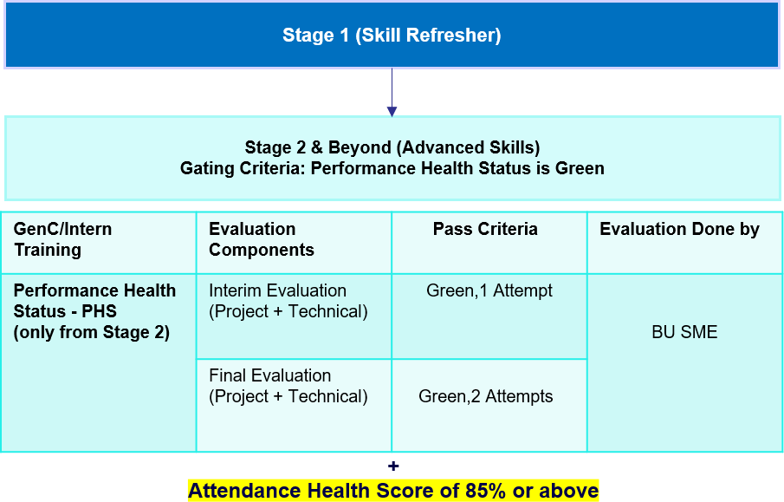

GenC FTE skilling program guidelines

All GenCs are expected to adhere to and uphold the Cognizant Code of Ethics (“Code”) to help ensure that
everything they do at Cognizant is in accordance with our standards of integrity.
The guidelines are to support the GenC FTE candidates stay focused and on-track w.r.t successful completion of the training program.
- Non-adherence of the below guidelines for more than 2 times to any of the below will be considered as a breach leading to de-enrollment from Internship program and revocation of LOI.

  - Code of Ethics
  - Adherence to Attendance*
  - Integrity in assessments**
  - Dress code
  - Adherence to communication Protocols
Note:
- In case of a breach in any of the above stated, the GenC FTE candidate will be issued a warning by the respective Batch Owner.
- It is recommended that the associate responds to the warning mailer with an explanation.
- If any GenC FTE candidate is given more than 2 warnings, it will lead to immediate de-enrollment from the GenC FTE skilling program and employment termination.
- Non-Adherence to attendance requirements * & lack of integrity in assessments** will lead to stringent disciplinary action as per organization policies, including in de-enrollment from the Internship program and revocation of the LOI.

Please refer below to know about the key policies and guidelines that will govern the GenC FTE skilling in alignment with the organization policies:

Guideline | Description | Link
Code of ethics | The behavior and professionalism of each Associate are critical to creating a safe and harmonious work environment where everyone can thrive and be stewards of Cognizant’s reputation, impact, and success. | Code of ethics
Integrity in assessments | Any learning and assessment are expected to be given by the GenCs in a very honest way. Plagiarism / copying / any malpractice has a zero tolerance
Dress code | Our Dress code policy expects our employees to use their best judgment in deciding how they dress at work. | Dress code policy
Communication protocols | All Cognizant associates are expected to comply with the organization’s Communications & social media Policy | Cognizant 'Communications & Social Media' Policy
Acceptable use policy | https://cognizantonline.sharepoint.com/sites/CorporateFunctions/Shared%20Documents/Legal%20Folder/Global%20Corporate%20Policies/Global%20Policies/aup-policy.pdf
Acceptable use policy | https://cognizantonline.sharepoint.com/sites/CorporateFunctions/Shared%20Documents/Legal%20Folder/Global%20Corporate%20Policies/Global%20Policies/aup-policy.pdf
Mandatory social media training | https://cognizantlearning.sumtotal.host/rcore/c/pillarRedirect?relyingParty=LM&url=app/management/LMS_ActDetails.aspx?ActivityId%3d1943087%26UserMode%3d0
Prevention of Sexual Harassment Policy - India | https://cognizantonline.sharepoint.com/sites/GlobalHR/Shared%20Documents/Operations/Global%20HR%20Policies/Global%20HR%20Policies%20-%20Regional/India/Prevention%20of%20Sexual%20Harassment%20Policy.pdf  In case of any SH related issues, kindly reach out directly to your location Prevention of Sexual Harassment Committee. Refer to the above policy link for email id of the location wise committee.
Job Abandonment Policy | https://cognizantonline.sharepoint.com/sites/GlobalHR/Shared%20Documents/Operations/Global%20HR%20Policies/Global%20HR%20Policies%20-%20Regional/India/Job%20Abandonment%20Policy.pdf?web=1
Global Associate Privacy Notice | https://cognizantonline.sharepoint.com/:b:/r/sites/CorporateFunctions/Shared%20Documents/Legal%20Folder/Global%20Corporate%20Policies/Global%20Policies/global-privacy-policy.pdf?csf=1&web=1&e=OamSqd
Whistleblower & Non-Retaliation Policy | https://cognizantonline.sharepoint.com/:b:/r/sites/CorporateFunctions/Shared%20Documents/Legal%20Folder/Global%20Corporate%20Policies/Global%20Policies/whistleblower-and-non-retaliation-policy.pdf?csf=1&web=1&e=V48j4k

CODE OF ETHICS - GUIDING PRINCIPLES
Misconduct can be broadly defined as a behavior or a failure to act in line with the company’s values,
standards, policies, procedures, or other documents regulating the employment relationship.
The list below provides examples of misconduct; however, this is only illustrative and not deemed to be an exhaustive list.

Employee Relations matters

      - Refusing to follow reasonable work instructions from a supervisor
      - Habitual absenteeism and late reporting to work,
      - unscheduled or unapproved leave impacting individual performance or teamwork.
      - Negative language in the Work Environment
      - Behaviors impacting productivity.
      - Inter-personal conflict
      - Borrowing and lending money to peers
      - Inappropriate leadership behavior

ATTENDANCE HEALTH SCORE GUIDELINES
- All GenC FTE trainees are expected to be available for the training at a physical location for all the 5 days in a week.
- Attendance at the physical location & virtual training as applicable must be at least 85% every month to successfully complete the FTE Skilling program
- The TruTime hours logged should comply to Cognizant Working Hours guidelines
- 100% attendance is mandatory in all Instructor led sessions (ILT)
- The total number of hours for mandatory video-based sessions (both technical & behavioural sessions) will be considered for AHS calculation.
  - FTE trainees must be on video to have attendance for all VILT (Virtual Instructor Led Training) sessions.
    - Any breach of this evidenced in email with a concern raised by instructor/Batch Owner/L&D team will call for attendance not marked for the session and invite a warning resulting in consequence.

AHS RAG
      - The GenC FTE trainee attendance will be reported as AHS RAG
      - GenC FTE trainee attendance reports will be generated every fortnight and the cumulative weekly AHS RAG status for each month must be in “Green”
      - The AHS RAG status will be calculated and reported based on:
        - TruTime hours
        - Attendance in mandatory ILT/VILT sessions (manual report of both technical & behavioural sessions)
85% attendance in both the above parameters is mandated. AHS calculation matrix will be as below:

Actual Trutime | Actual session hours reported | RAG
>=85% | >=85% | Green
>=80% & <85% | >=85% | Amber
>=85% | >=80 & <85% | Amber
<85% | <85% | Red

AHS Consequence
Monthly AHS RAG | Consequence
 | GenC
Green | Continue with the skilling program
Amber | De-enrolment from the skilling program. revoked LOI
Red

FTE leave policy
      - Attendance to be followed as per the AHS guidelines
      - It is mandatory to be in-person or on video for VILT sessions (concern raised by facilitator will be a breach)
      - Uninformed leaves of more than 3 days will lead to consequence
      - 3 to 4 months in office are mandatory. If the trainees do not have 85% attendance in a month (both physical & virtual), it would lead to unsuccessful completion of the skilling program.
      - Leave approvals to be taken in advance through their GenC Batch Owner – Validated medical leaves from Cognizant medical team only will be permitted
      - Notify the GenC Batch Owner immediately for any Sick/Emergency leave – medical reports to be validated through Cognizant medical team
      - All other leaves in any other reasons/categories would have an impact in the AHS attendance. Any uninformed leave(s) would lead to consequence as per AHS guidelines.
      - GenC FTE trainees are expected to have uninterrupted access to office mail and are always reachable on mobile phone numbers and MS Teams
      - Attendance proxy both giving on behalf of others or availing the act would warrant serious consequence.
      - Uninformed Leave >3 days will be moved to No-Show case and Job abandonment will be initiated for GenC FTE.

Break Scenario

In cases where a GenC FTE candidate is unable to attend training for more than five consecutive working days due to genuine medical or personal emergencies, they may be considered for movement to a Break Cohort, subject to approval from the Program Manager. Once approved, the Batch Owner will update the CRecruit and coordinate with the Supply Management Team to initiate the process. The GenC should be informed in advance, and a tentative rejoining date must be obtained. Upon return, the GenC will be mapped to a cohort based on current demand, which may differ from their original training track. Flexibility in accepting the available technology track is expected.

During the break period, the GenC is advised to apply for Leave/LOP, which may also be initiated by the Batch Owner in HCM. If the GenC does not report back on the agreed date and remains unresponsive for three working days, a Job Abandonment (JA) will be raised on the fourth day.

Rejoining scenarios are handled as follows:

      - If the GenC returns before the agreed date, they must obtain approval from the Batch Owner to cancel the LOP and raise a GSD request.
      - If the GenC returns on the agreed date, the Batch Owner will confirm cohort availability with the Supply Management Team and facilitate reassignment accordingly.

Throughout the process, the Batch Owner must ensure timely communication with all relevant stakeholders, including the Trainer, Program Managers, Platform Team, and Supply Management Team, to ensure a smooth transition and continuity in training.

INTEGRITY IN ASSESSMENTS
Any learning and assessment are expected to be given by the GenCs in a very honest way. Plagiarism / copying / any malpractice has zero tolerance.
The type of disciplinary action(s) would be based on multiple factors attached to the incident and incidents with high severity may call for stringent disciplinary action as per organization policies.

What constitutes Malpractice
S. No | Scenarios | S. No | Scenarios
1 | Trying to capture and leak questions and/or answers, in ANY mode – mobile pictures, screenshots, streaming etc., | 11 | False declaration of authenticity in relation to the submission of coursework to become eligible for a test.
2 | Copying code or answers or helping to copy from ANY source | 12 | Wasting an attempt to just look at or capture questions
3 | Informing any other parties about the details of the questions and answers, either before or after the assessment through any medium, including verbal  or electronic. | 13 | Spurious complaints about system or infra related issues to explain failed attempt
4 | Having someone else take the test for you or help you with the answers in any way or mode. | 14 | Any attempt to compromise the integrity of the exam through any electronic or non-electronic method
5 | Running a parallel test session to gauge questions. | 15 | Trying to look in the other person’s desktop in the assessment hall
6 | Attempt to take assessments in groups | 16 | Discussion in the assessment hall before starting the test/ while attempting or even after  finishing your test
7 | Using any electronic devices to capture exam related data or look for answers through any channels. | 17 | Trying to pass answers via rough sheet or any by any other source.
8 | Fabrication of results or evidence | 18 | Using Bluetooth devices during the assessment
9 | Stepping out of assessment hall more than once for drinking water or any other personal reasons. | 19 | Using nonverbal communication facial expressions, gestures, paralinguistics (such as loudness or tone of voice), body language, eye gaze
10 | Carrying any additional paper, cheat sheet to the assessment hall

Deployment guidelines
As a full-time employee, trainees will be required to show:
- Flexibility to work out of any of our Cognizant Location(s), as per the training/ project requirements.
- Ready to work in any shift, as per the training/project requirement.

- Ready to work in technology as per the final graduated skilling track.

Communication protocols

GenC Program Communication Escalation Matrix
“Whom shall I reach out to in case of any query”
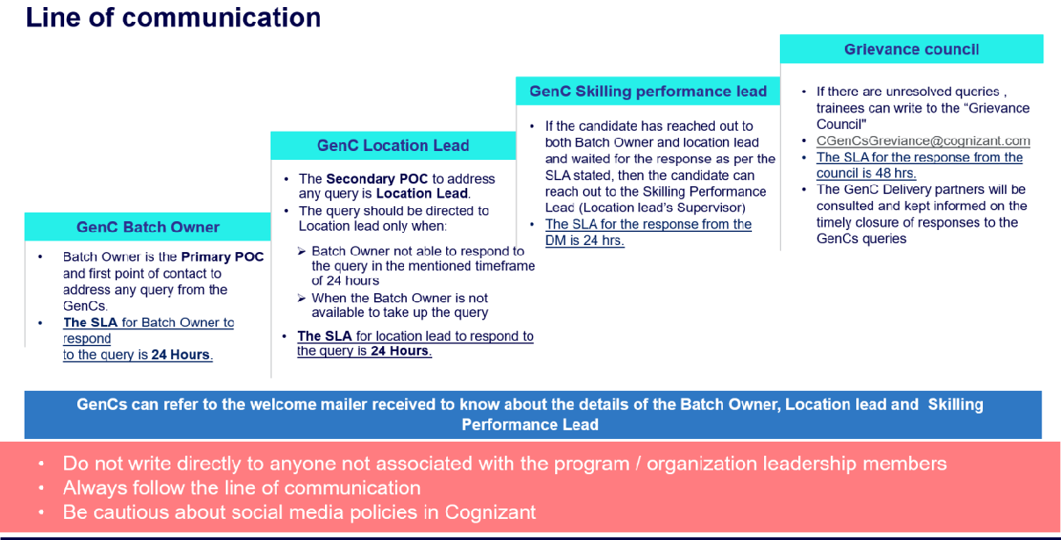

Mail format
It is highly recommended that the GenC FTE trainees follow the format below while writing regarding their queries for faster resolution

Mail Template

Subject: <<Cohort Code>>_<<Employee ID>> - brief of the issue/query
Employee ID
Name
DOJ | DD-MM-YY
SL
Cohort Code
Batch Owner Name
Delivery Lead Name
Have you reached out to your Batch Owner and SL POC earlier? | Yes/No/NA  If no, reach out to your respective PoC. Please send this query to

 | DL only if it is not addressed by both your Batch Owner/Delivery Lead.
Query not addressed by Leads/Batch Owners | Explain in 2-3 lines. Attach email proof of the query which was not addressed by Batch Owner/Lead within 48Hours

GenC Grievance cell
The objective of the grievance cell is to provide a good learning experience & working relationship for the GenC FTE trainees throughout their journey with the GenC skilling program.
The cell encourages the GenC FTE trainees to express their grievances / problems freely and frankly, without any fear of being victimized
The Grievance cell will focus on advising the trainees to show utmost restraint and patience whenever any occasion of issue/challenges to follow escalation matrix not write to cognizant leadership or write in public domain. Also, advise all GenC program POCs to be more approachable to the GenC FTE trainees and not be unresponsive to their concerns.

How does the grievance cell work?
Raising grievance is a 3 steps process wherein the GenC FTE trainees can log their grievance to the cell which will be tracked, monitored, and closed by the Grievance committee
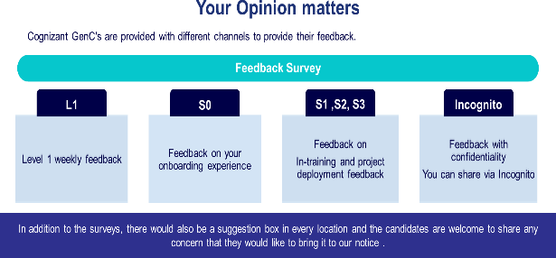
- Through Incognito survey which will be launched in a specified frequency/timeline during the skilling journey
- Common mailbox for Grievance GrievanceCoreTeam@cognizant.com where the concerns can be emailed.
- Suggestion drop box placed in all physical locations wherein the GenCs FTE trainees can drop a grievance note.
Link to Incognito survey: https://forms.office.com/r/6ZK0uBkEYJ



Grievance Categories
SME Evaluation failures in 1st, 2nd and both the attempts | Warning given by the Batch Owners on the guideline breach  - Dress code guideline violation  - Misconduct covering Behavioral, Values and Ethics etc.  - Malpractice aligned to lack of learning agility  - Communication breach  - Training at physical location and AHS attendance
Stipend not received on time/Stipend amount is incorrect
Issues with company assets
Issues with company learning platform
Issues with Internal & external SMEs conduct
Issues related to BGV, onboarding process and offer letter

Feedback communication to the GenC
Performance status will be communicated to GenC FTE trainees at the appropriate checkpoints and will be available on the GenC learning platform dashboard.

The consequence-based feedback will be provided to the GenC FTE trainees based on the performance status at Checkpoint.

- On Track for successful completion (Green)

- Improvement Recommended (Amber)

- Critical focus required on progress (Red)

OUTLIERS/EXCEPTIONS
Any GenC NOT falling under ‘Successfully completed’ or ‘Alternate Service Line’ will not be applicable for
the report card from Cognizant GenC skilling program.



GenC FTE Skilling 2025 Performance Declaration Form
I , undergoing skilling in the GenC FTE skilling program via
classroom/virtual mode will be obliged to abide by, acknowledge, and agree to the following:
“GenC FTE skilling completion guidelines 2025” applicable to all types of skilling programs
(Skilling/Re-skilling pre & post onboarding)
Successful completion of the FTE skilling program is mandatory for eligibility to continue as an FTE & be deployed to Projects.
Flexibility regarding location, shift, role, and technology is required during training and project deployment.
The GenC FTE skilling completion guidelines 2025 document outlines the guidelines and criteria for successful completion of the GenC FTE skilling program:
Performance indicators such as Performance Health Status (PHS - GREEN) and Attendance Health Status (AHS – 85%) are mandatory for successful completion. If a

Performance Standards

Hands-On Completion

Mandatory Assessments

Zero Tolerance for Malpractices

Attendance Requirement

Exceptions

Reporting Discrepancies

Concerns post-unsuccessful completion
GenC FTE trainee fails to meet the performance standards of the skilling program within the stipulated timeline, the trainee will be ineligible for project deployment and continued employment with the organization. HR will initiate Trainee Consequence Management procedures.
100% completion of hands-on exercises at each stage is mandatory for eligibility to progress to the next stage.
Clearing the Stage-1 assessment and final evaluation is mandatory for successful completion of training and eligibility for deployment to Business Units (BU) in skilling or re-skilling programs.
Any form of malpractice will be dealt with zero tolerance, potentially leading to immediate de-enrollment from the program and revocation of the LOI.
All GenC FTEs must maintain minimum 85% attendance at the physical location and virtual training as applicable every month to continue and successfully complete the program.
There could be exceptions to the applicability of evaluation components and deployment clauses based on demand and training outcomes, subject to ISL discretion and GenC program head approval.
Any discrepancies or deviations observed in the defined process or procedure should be reported to the respective Learning point of contact immediately during the learning journey.
Concerns raised after failing to meet the expected performance health indicators will not be considered as exceptions to the consequence management process.


Employee Name: Rathish S
Location
: Chennai-SRZ Date: 24 / 03 /2026
Employee ID : 2489635
Signature : 